* **Explain Step DBAdapter in SOA Application**

**Ans: -**

**Why Database Adapter?**

Service Oriented Architecture is all about services, its about your entire business application modeled as Services. In a Business Application, it is obvious that you need database to interact with. But a database by itself cannot be exposed as a service. For ex, in order to interact with it, you need to write a Java program, and using JDBC connectivity, you connect and interact with the database.

And Oracle SOA Suite 11g provides a similar solution to it called a Database Adapter. With this, you can use your existing database as a service in your SOA Application.

It also provides various other functionalities like polling a database, checking for any changes in a specific table in a database, etc.

**Working with a DBAdapter**

Create a new SOA Project, name it **DBAdapterExample**

This creates a new project folder, with an empty composite.xml

You need to first define the input and output xml formats used in the example.

In this example, Input is EmployeeId(Int) and Output is FullName, Salary

Create a new XML schema that has 2 nodes with input and output format types

rt click on xsd folder in the project --> new XML Schema, name it **DBAdapterFormat.xsd**

[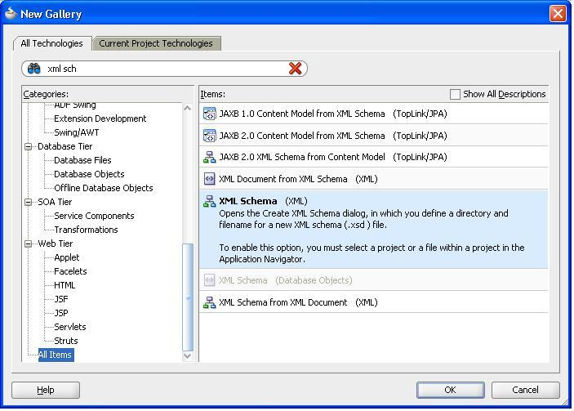](http://3.bp.blogspot.com/-1kO-2M2BjeE/UD3asMsNQLI/AAAAAAAAAB8/ACzcgKl7RIw/s1600/2.JPG)

Define the schema as below

[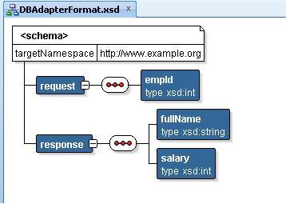](http://3.bp.blogspot.com/-YXZY1rGQkNE/UD3atajfdWI/AAAAAAAAACE/CI5Z0a9HHlI/s1600/3.JPG)

Creating a Database Adapter

* Drag and Drop a Database Adapter from the Component Pallette, into the "External References" swimline in the composite.xml, name it **EmpDBAdapterService**
* Create a database connection, and give the ***JNDI name for the outbound connection pool*** for the DBAdapter that you've configured(verify my prev<*link*> post for this)
* Select the operation that you want, Select in this case
* Import the database table you want to interact with, Employees in this case
* You may remove the relationships that you see in Step 6, or leave it as it is
* Select all the fields that you will use in this application(no problem if you even select all and later on do not use it)
* In Step 8, you have to create a bind variable(parameter), and use it in the where clause of the SQL query. In this example, we send the employeeId, and so, create a bind variable by some name(bndEmpId), and use it in the where clause as shown
* Finish the wizard to last step, and you will see a new Database Adapter in the composite.xml

[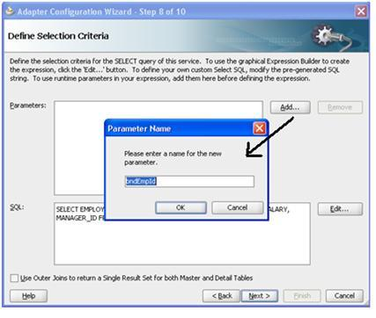](http://2.bp.blogspot.com/-Xb1oc_b1GbQ/UD3axnj5QTI/AAAAAAAAACc/rrTHUrbsUsI/s1600/6.jpg)

[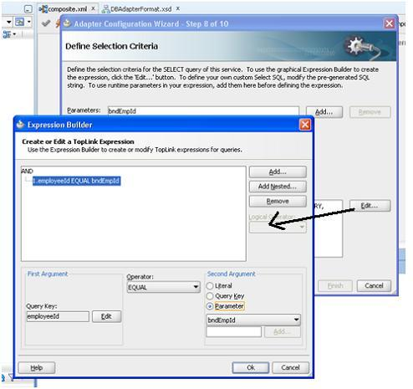](http://1.bp.blogspot.com/-qGSpo9YHOoI/UD3azP10SnI/AAAAAAAAACk/RGM5Q64iO9k/s1600/7.jpg)

[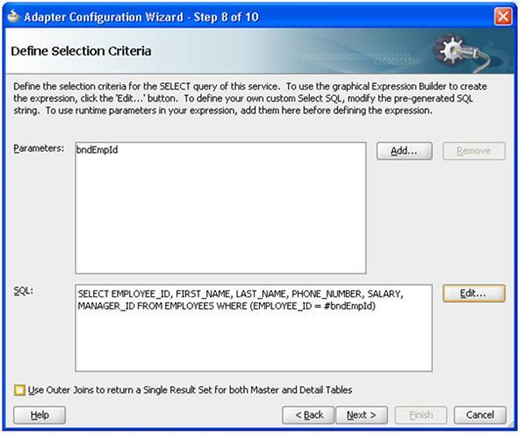](http://1.bp.blogspot.com/-_rlL40xHQyM/UD3a1WSoJQI/AAAAAAAAACs/iqTKZnztOok/s1600/8.jpg)

[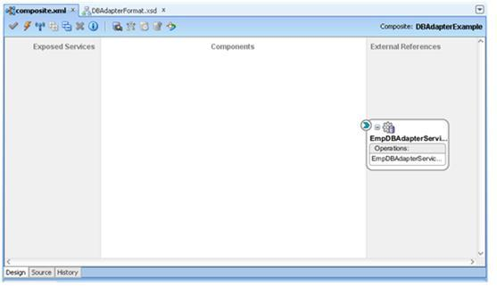](http://3.bp.blogspot.com/-p_mcejAtrlw/UD3a2v602YI/AAAAAAAAAC0/0g-AsX-wzhQ/s1600/9.jpg)

Now that DBAdapter is created, in other words, the underlying database is exposed as a service, you can talk to the service to get its data.

But since the service is not exposed directly to clients (Services only in Exposed Services swim lane can be accessed by external clients)

So, you now have to create an exposed web service whose input and output parameters are same as the Database Adapter. Please remember that the Exposed service is just a client to access the Database Adapter, and has no relevance to the database or its created Adapter.